**Name: STEBIN BABU**

**Roll No: 44**

**Batch:B**

**Date: 19-04-2022**

**ADVANCED DBMS LAB**

**Experiment No.: 4**

**Aim**

To familiarize with aggregate functions

**QUESTION**

1.List total loan

2.List total deposit

3.List total loan taken from KAROLBAGH branch

4.List total deposit of customers having account date later than 1-Jan-96

5.List total deposit of customers living in city NAGPUR

6.List maximum deposit of customer living in Bombay

7.List total deposit of customer having branch in BOMBAY

8.Count total number of branch cities

9.Count total number of customers cities

10.Give branch names and branch wise deposit

11.Give city wise name and branch wise deposit

12.Give the branch wise loan of customer living in NAGPUR

13.Count total number of customers

14.Count total number of depositors branch wise

15.Count total number of depositors branch wise

16.Give maximum loan from branch VRCE

17.Give the number of customers who are depositors as well as borrowers

**PROCEDURE AND OUTPUT SCREENSHOT**

1. 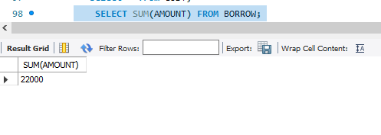

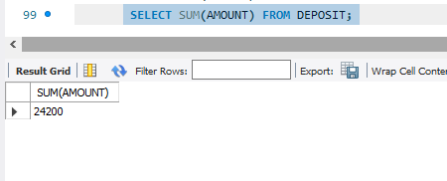 **2.**

**3.**

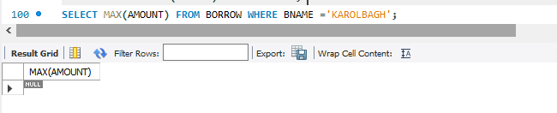

**4.**

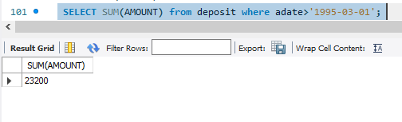

**5.**

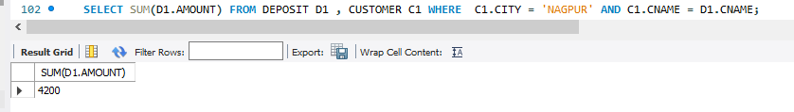

**6.**

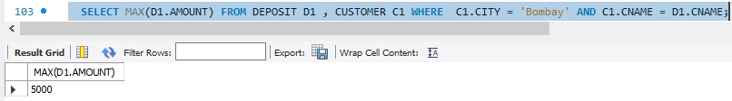

**7.**

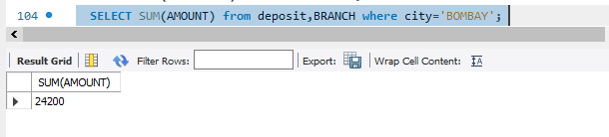

**8.**

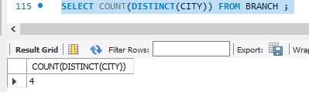

**9.**

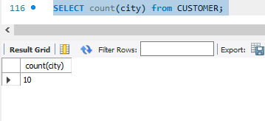

**10.**

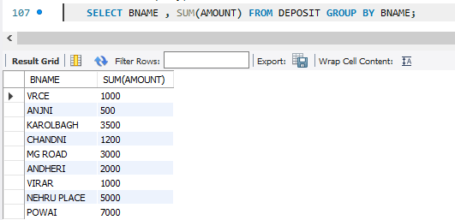

**11.**

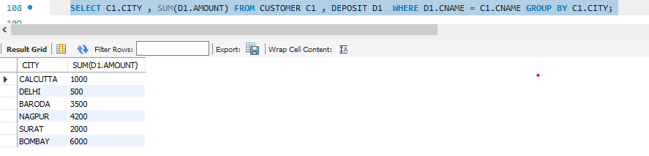

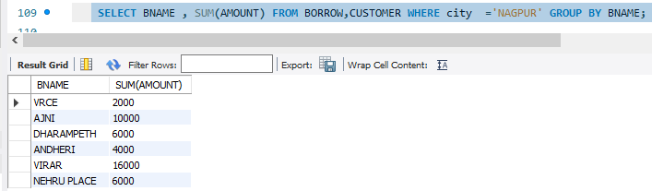**12.**

**13.**

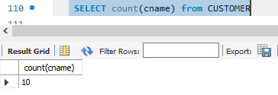

**14.**

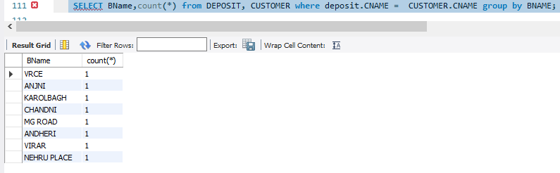

**15.**

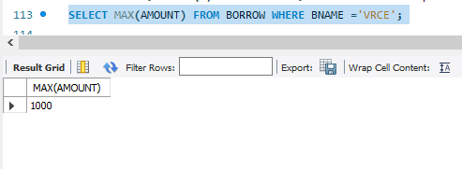

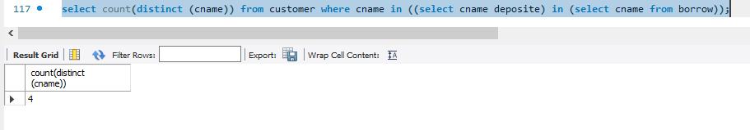**16.**